Is Java a Compiled or Interpreted Language?

## <https://www.baeldung.com/java-compiled-interpreted>

## 1. Overview

Programming languages are classified based on their levels of abstraction. We differentiate high-level languages (Java, Python, JavaScript, C++, Go), low-level (Assembler), and finally, machine code.

Every high-level language code, like Java, **needs to be translated to machine native code for execution.** This translation process can be either compilation or interpretation. However, there is also a third option. A combination that seeks to take advantage of both approaches.

In this tutorial, we'll explore how Java code gets compiled and executed on multiple platforms. We'll look at some Java and JVM design specifics. These will help us determine whether Java is compiled, interpreted, or a hybrid of both.

## 2. **Compiled vs. Interpreted**

Let's start by looking into some basic differences between compiled and interpreted programming languages.

### 2.1. **Compiled Languages**

Compiled languages (C++, Go) are converted directly into machine native code by a compiler program.

They require an explicit build step before execution. That is why we need to rebuild the program every time we make a code change.

**Compiled languages tend to be faster and more efficient**than interpreted languages**.** However, their generated machine code is platform-specific.

### 2.2. Interpreted Languages

On the other hand, in interpreted languages (Python, JavaScript), there are no build steps. Instead, interpreters operate on the source code of the program while executing it.

Interpreted languages were once considered significantly slower than compiled languages. However, with the development of just-in-time (JIT) compilation, the performance gap is shrinking. We should note, however, that JIT compilers turn code from the interpreted language into machine native code as the program runs.

Furthermore, we can **execute interpreted language code on multiple platforms**like Windows, Linux, or Mac. Interpreted code has no affinity with a particular type of CPU architecture.

## 3. Write Once Run Anywhere

[Java and the JVM](https://www.baeldung.com/jvm-languages) were designed with portability in mind. Therefore, most popular platforms today can run Java code.

This might sound like a hint that Java is a purely interpreted language. However, before execution, **Java source code needs to be compiled into**[**bytecode**](https://www.baeldung.com/java-class-view-bytecode)**. Bytecode is a special machine language native to the JVM.**The JVM interprets and executes this code at runtime.

It is the JVM that is built and customized for each platform that supports Java, rather than our programs or libraries.

Modern JVMs also have a JIT compiler. **This means that the JVM optimizes our code at runtime** to gain similar performance benefits to a compiled language.

## 4. Java Compiler

The **[javac](https://www.baeldung.com/javac) command-line tool compiles Java source code into Java class files** containing platform-neutral bytecode:

$ javac HelloWorld.java

Source code files have .java suffixes, while the class files containing bytecode get generated with .class suffixes.

[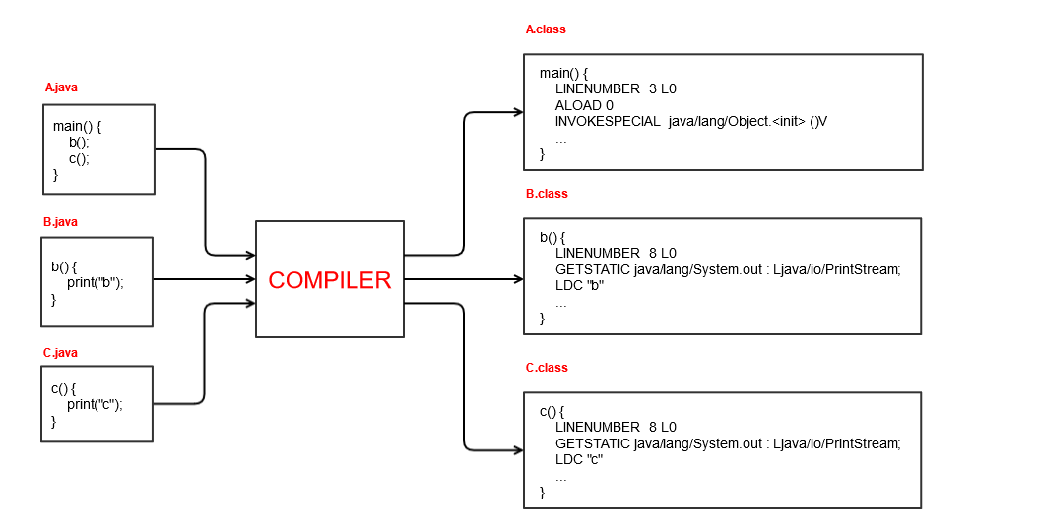](https://www.baeldung.com/wp-content/uploads/2021/01/java_compilation-3.png)

## 5. Java Virtual Machine

The compiled class files (bytecode) can be [executed](https://www.baeldung.com/java-single-file-source-code) by the [Java Virtual Machine (JVM)](https://www.baeldung.com/jvm-vs-jre-vs-jdk):

Furthermore, we can **execute interpreted language code on multiple platforms**like Windows, Linux, or Mac. Interpreted code has no affinity with a particular type of CPU architecture.

## 3. Write Once Run Anywhere

[Java and the JVM](https://www.baeldung.com/jvm-languages) were designed with portability in mind. Therefore, most popular platforms today can run Java code.

This might sound like a hint that Java is a purely interpreted language. However, before execution, **Java source code needs to be compiled into**[**bytecode**](https://www.baeldung.com/java-class-view-bytecode)**. Bytecode is a special machine language native to the JVM.**The JVM interprets and executes this code at runtime.

It is the JVM that is built and customized for each platform that supports Java, rather than our programs or libraries.

Modern JVMs also have a JIT compiler. **This means that the JVM optimizes our code at runtime** to gain similar performance benefits to a compiled language.

## 4. Java Compiler

The **[javac](https://www.baeldung.com/javac) command-line tool compiles Java source code into Java class files** containing platform-neutral bytecode:

$ javac HelloWorld.java

Source code files have .java suffixes, while the class files containing bytecode get generated with .class suffixes.

[](https://www.baeldung.com/wp-content/uploads/2021/01/java_compilation-3.png)

## 5. Java Virtual Machine

The compiled class files (bytecode) can be [executed](https://www.baeldung.com/java-single-file-source-code) by the [Java Virtual Machine (JVM)](https://www.baeldung.com/jvm-vs-jre-vs-jdk):

The JIT compiler doesn't completely replace the interpreter. The execution engine still uses it. However, the JVM uses the JIT compiler based on how frequently a method is called.

**The JIT compiler compiles the entire method's bytecode to machine native code**, so it can be reused directly**.**As with a standard compiler, there's the generation to intermediate code, optimization, and then the production of machine native code.

A profiler is a special component of the JIT compiler responsible for finding hotspots. The JVM decides which code to JIT compile based on the profiling information collected during runtime.

[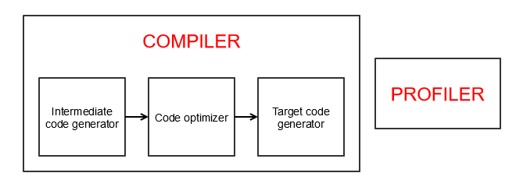](https://www.baeldung.com/wp-content/uploads/2021/01/jit_compiler1.png)

One effect of this is that a Java program can become faster at performing its job after a few cycles of execution. Once the JVM has learned the hotspots, it is able to create the native code allowing things to run faster.

## 6. Performance Comparison

Let's take a look at how the JIT compilation improves Java's runtime performance.

### 6.1. Fibonacci Performance Test

We'll use a simple recursive method to calculate the n-th Fibonacci number:

**private** **static** **int** **fibonacci**(**int** index) {

**if** (index <= 1) {

**return** index;

}

**return** fibonacci(index-1) + fibonacci(index-2);

}

In order to measure performance benefits for repeated method calls, we'll run the Fibonacci method 100 times:

**for** (**int** i = 0; i < 100; i++) {

**long** startTime = System.nanoTime();

**int** result = fibonacci(12);

**long** totalTime = System.nanoTime() - startTime;

System.out.println(totalTime);

}

First, we'll compile and execute the Java code normally:

$ java Fibonacci.java

Then, we'll execute the same code with the JIT compiler disabled:

$ java -Djava.compiler=NONE Fibonacci.java

Finally, we'll implement and run the same algorithm in C++ and JavaScript for comparison.

### 6.2. Performance Test Results

Let's take a look at the measured average performances in nanoseconds after running the Fibonacci recursive test:

* Java using JIT compiler – 2726 ns – fastest
* Java without JIT compiler  –  17965 ns – 559% slower
* C++ without O2 optimization –  9435 ns – 246% slower
* C++ with O2 optimization –  3639 ns – 33% slower
* JavaScript –  22998 ns – 743% slower

In this example, **Java's performance is more than 500% better using the JIT compiler**. However, it does take a few runs for the JIT compiler to kick-in.

Interestingly, Java performed 33% better than C++ code, even when C++ is compiled with the O2 optimization flag enabled. As expected, **C++ performed much better in the first few runs**, when Java was still interpreted.

Java also outperformed the equivalent JavaScript code run with Node, which also uses a JIT compiler. Results show more than 700% better performance. The main reason is that **Java's JIT compiler kicks-in much faster**.

## 7. Things to Consider

Technically, it's possible to compile any static programming language code to machine code directly. It's also possible to interpret any programming code step-by-step.

Similar to many other modern programming languages, Java uses a combination of a compiler and interpreter. The goal is to make use of the best of both worlds, **enabling high performance and platform-neutral execution**.

In this article, we focused on explaining how things work in HotSpot. HotSpot is the default open-source JVM implementation by Oracle. [Graal VM](https://www.baeldung.com/graal-java-jit-compiler) is also based on HotSpot, so the same principles apply.

Most popular JVM implementations nowadays use a **combination of an interpreter and a JIT compiler.** However, it's possible that some of them use a different approach.

## 8. Conclusion

In this article, we looked into Java and the JVM internals. Our goal was to determine if Java is a compiled or interpreted language. We explored the Java compiler and the JVM execution engine internals.

Based on that, we concluded that**Java uses a combination of both approaches.**

The source code we write in Java is first compiled into bytecode during the build process. The JVM then interprets the generated bytecode for execution. However, the JVM also makes use of a JIT compiler during runtime to improve performances.

As always, the source code is available [over on GitHub](https://github.com/eugenp/tutorials/tree/master/performance-tests).